Source file of fitting the data to the BPR function is [here](https://github.com/TheYuanLiao/speed2flow/blob/master/src/1-flow-fitting.ipynb).

The estimated flows using BPR as compared with the ground truth revealed the below problems.

1. The current analysis uses HERE road segments; however, they are assigned to multiple roads. And the sensors locations are not correctly mapped to the road segments. It raises the question, which road segment source do we use for this congestion analysis?
2. In terms of the performance of BPR, for most road segments, the function cannot identify the right parameters within their reasonable range (alpha < 1, beta is around 1.5). This was worse than the previous version of analysis when the direction was not considered. The poor R2 suggests that the input data quality is problematic for most of HERE road segments.

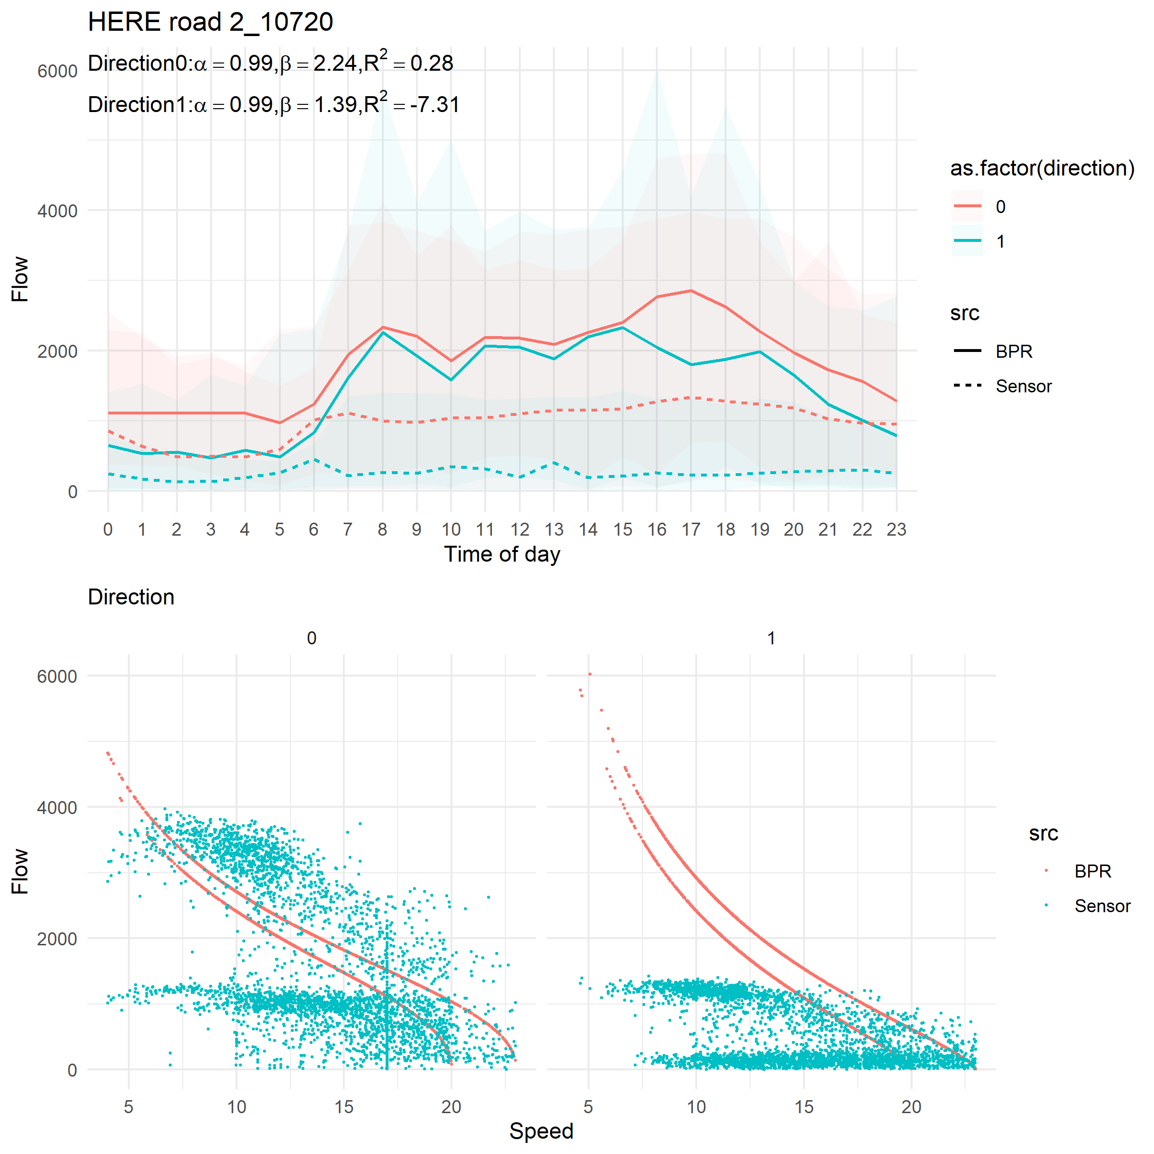

1. For some road segments, there are not enough data, or the data quality is low.

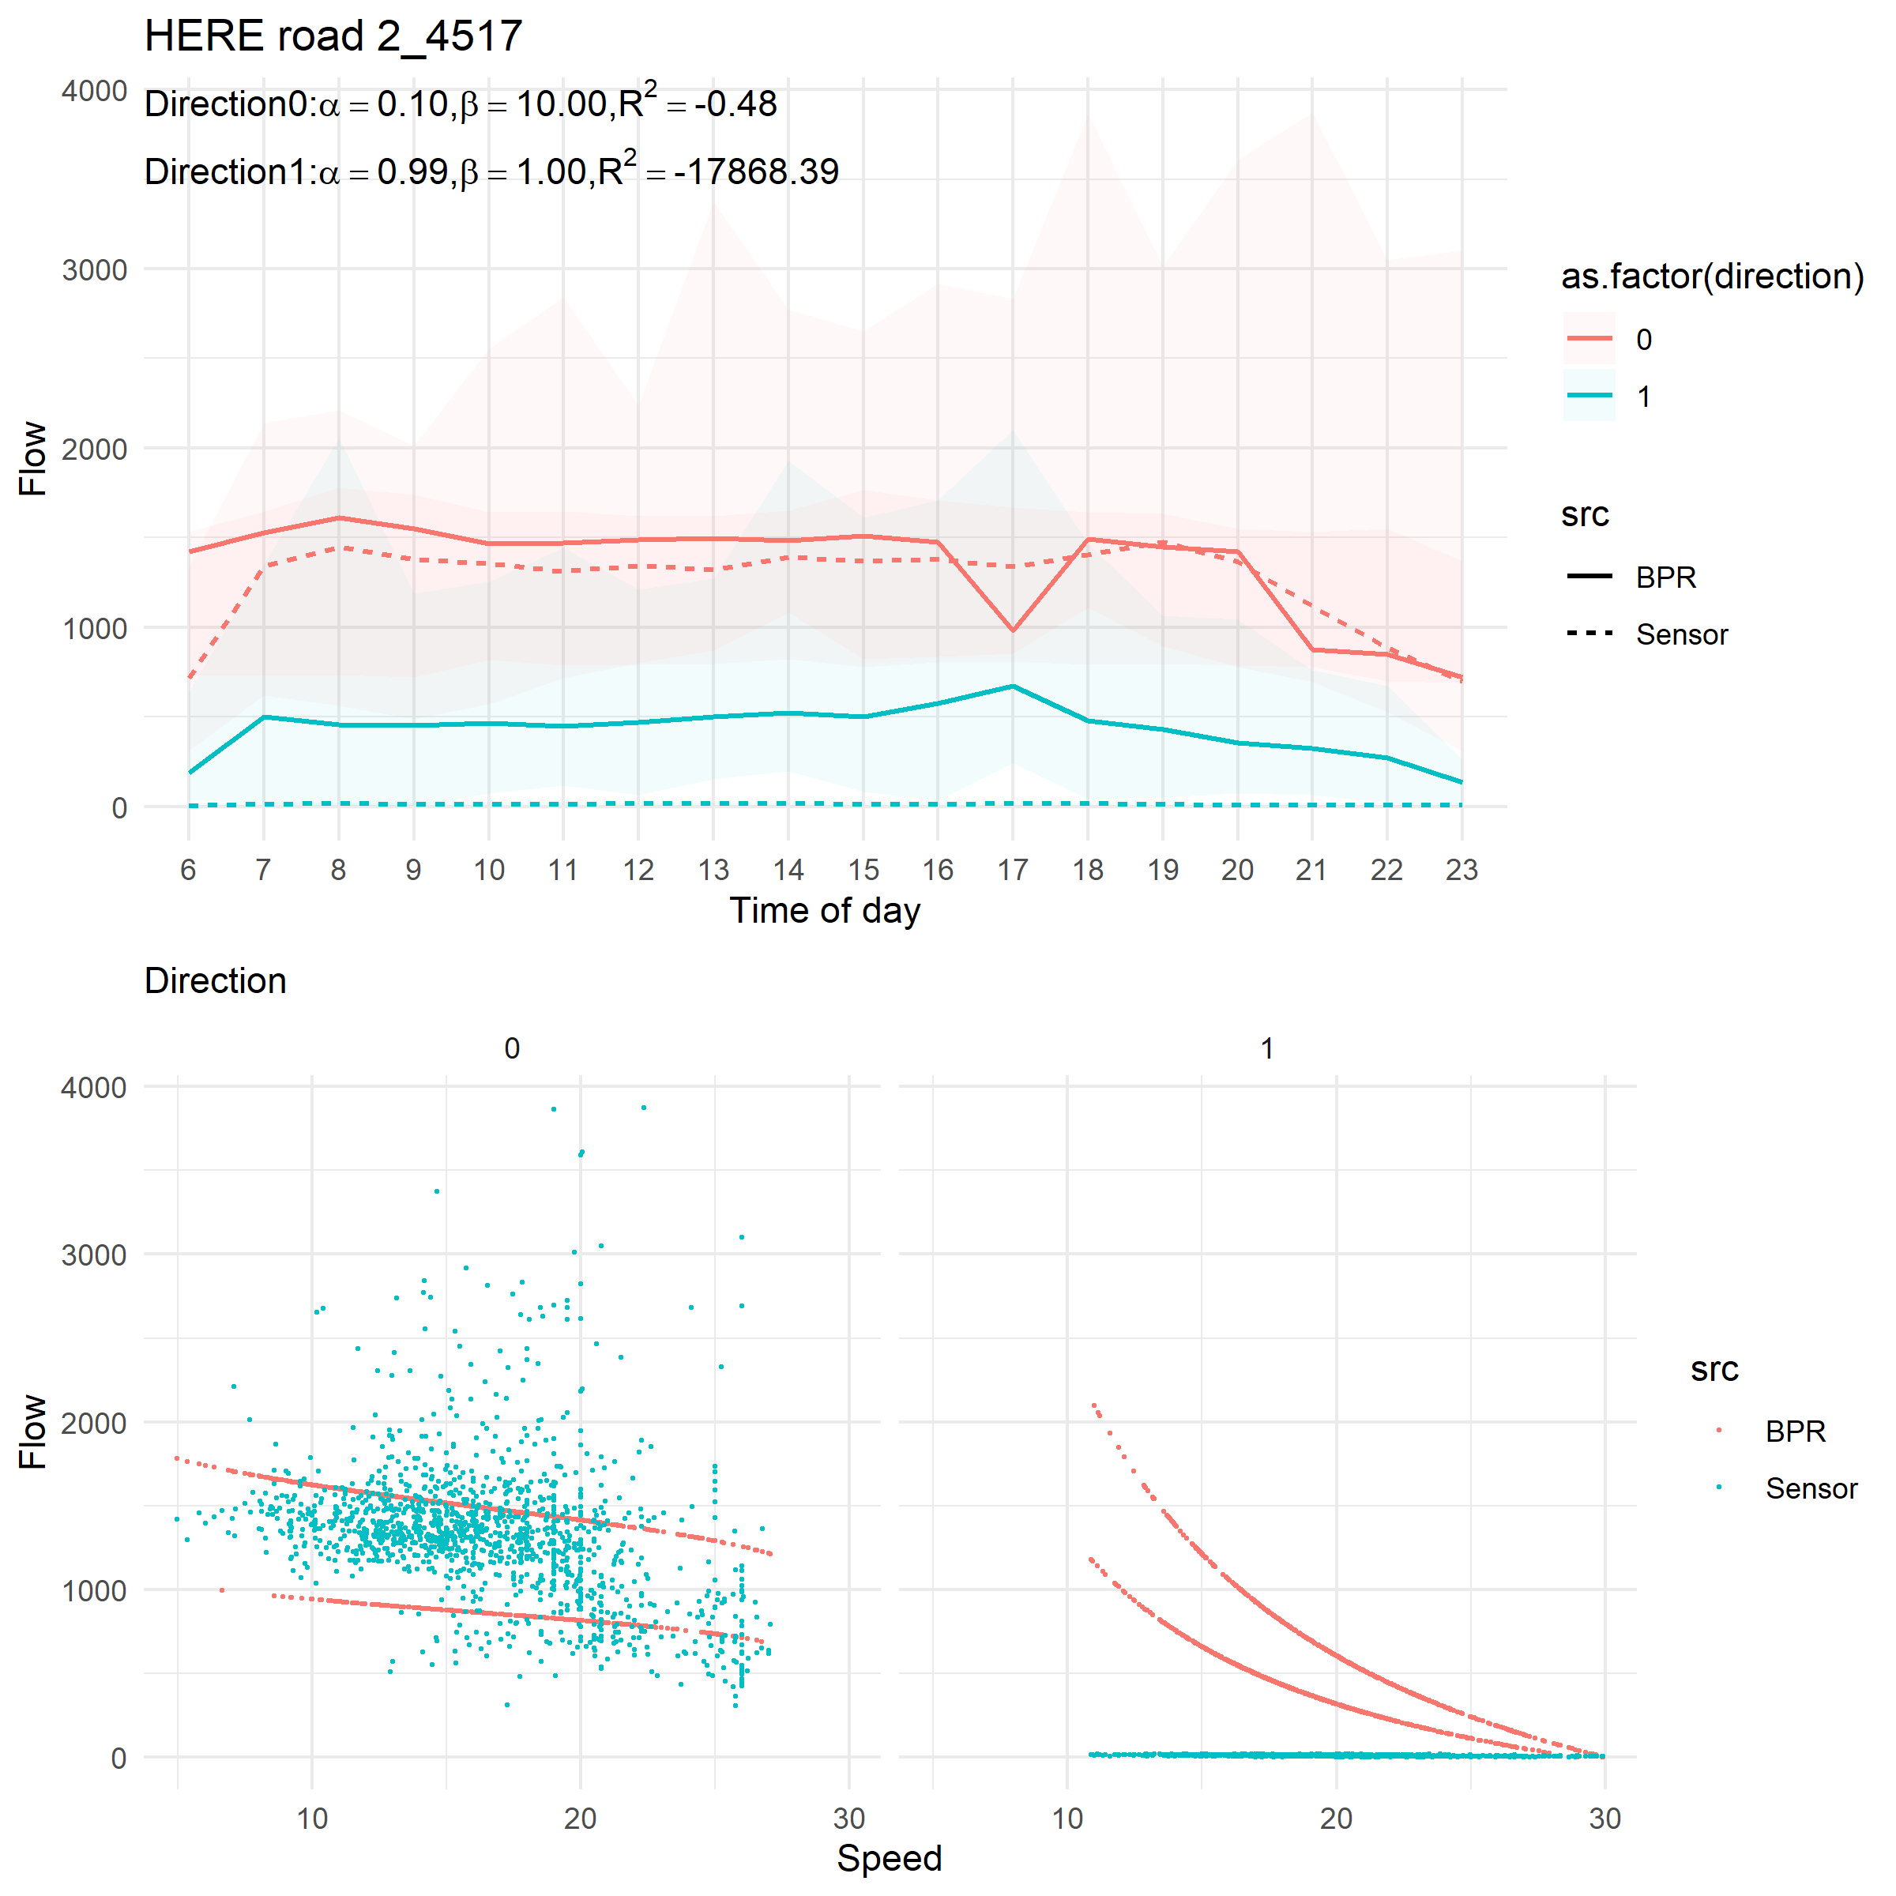

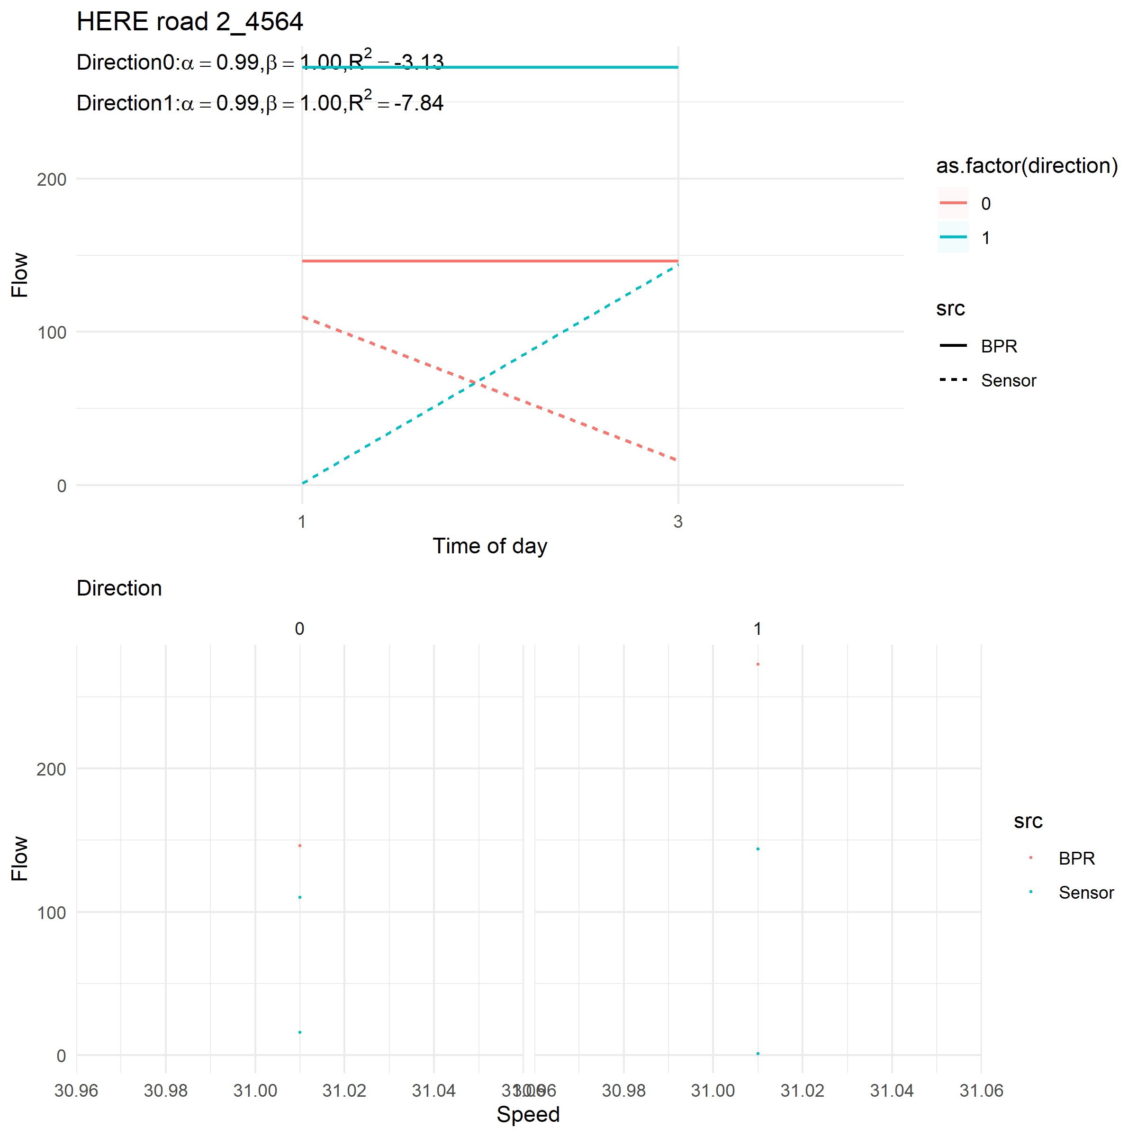

1. For some road segments, the BPR works fine despite the sensor’s location, OpenStreetMap road, and HERE road segments do not always match.

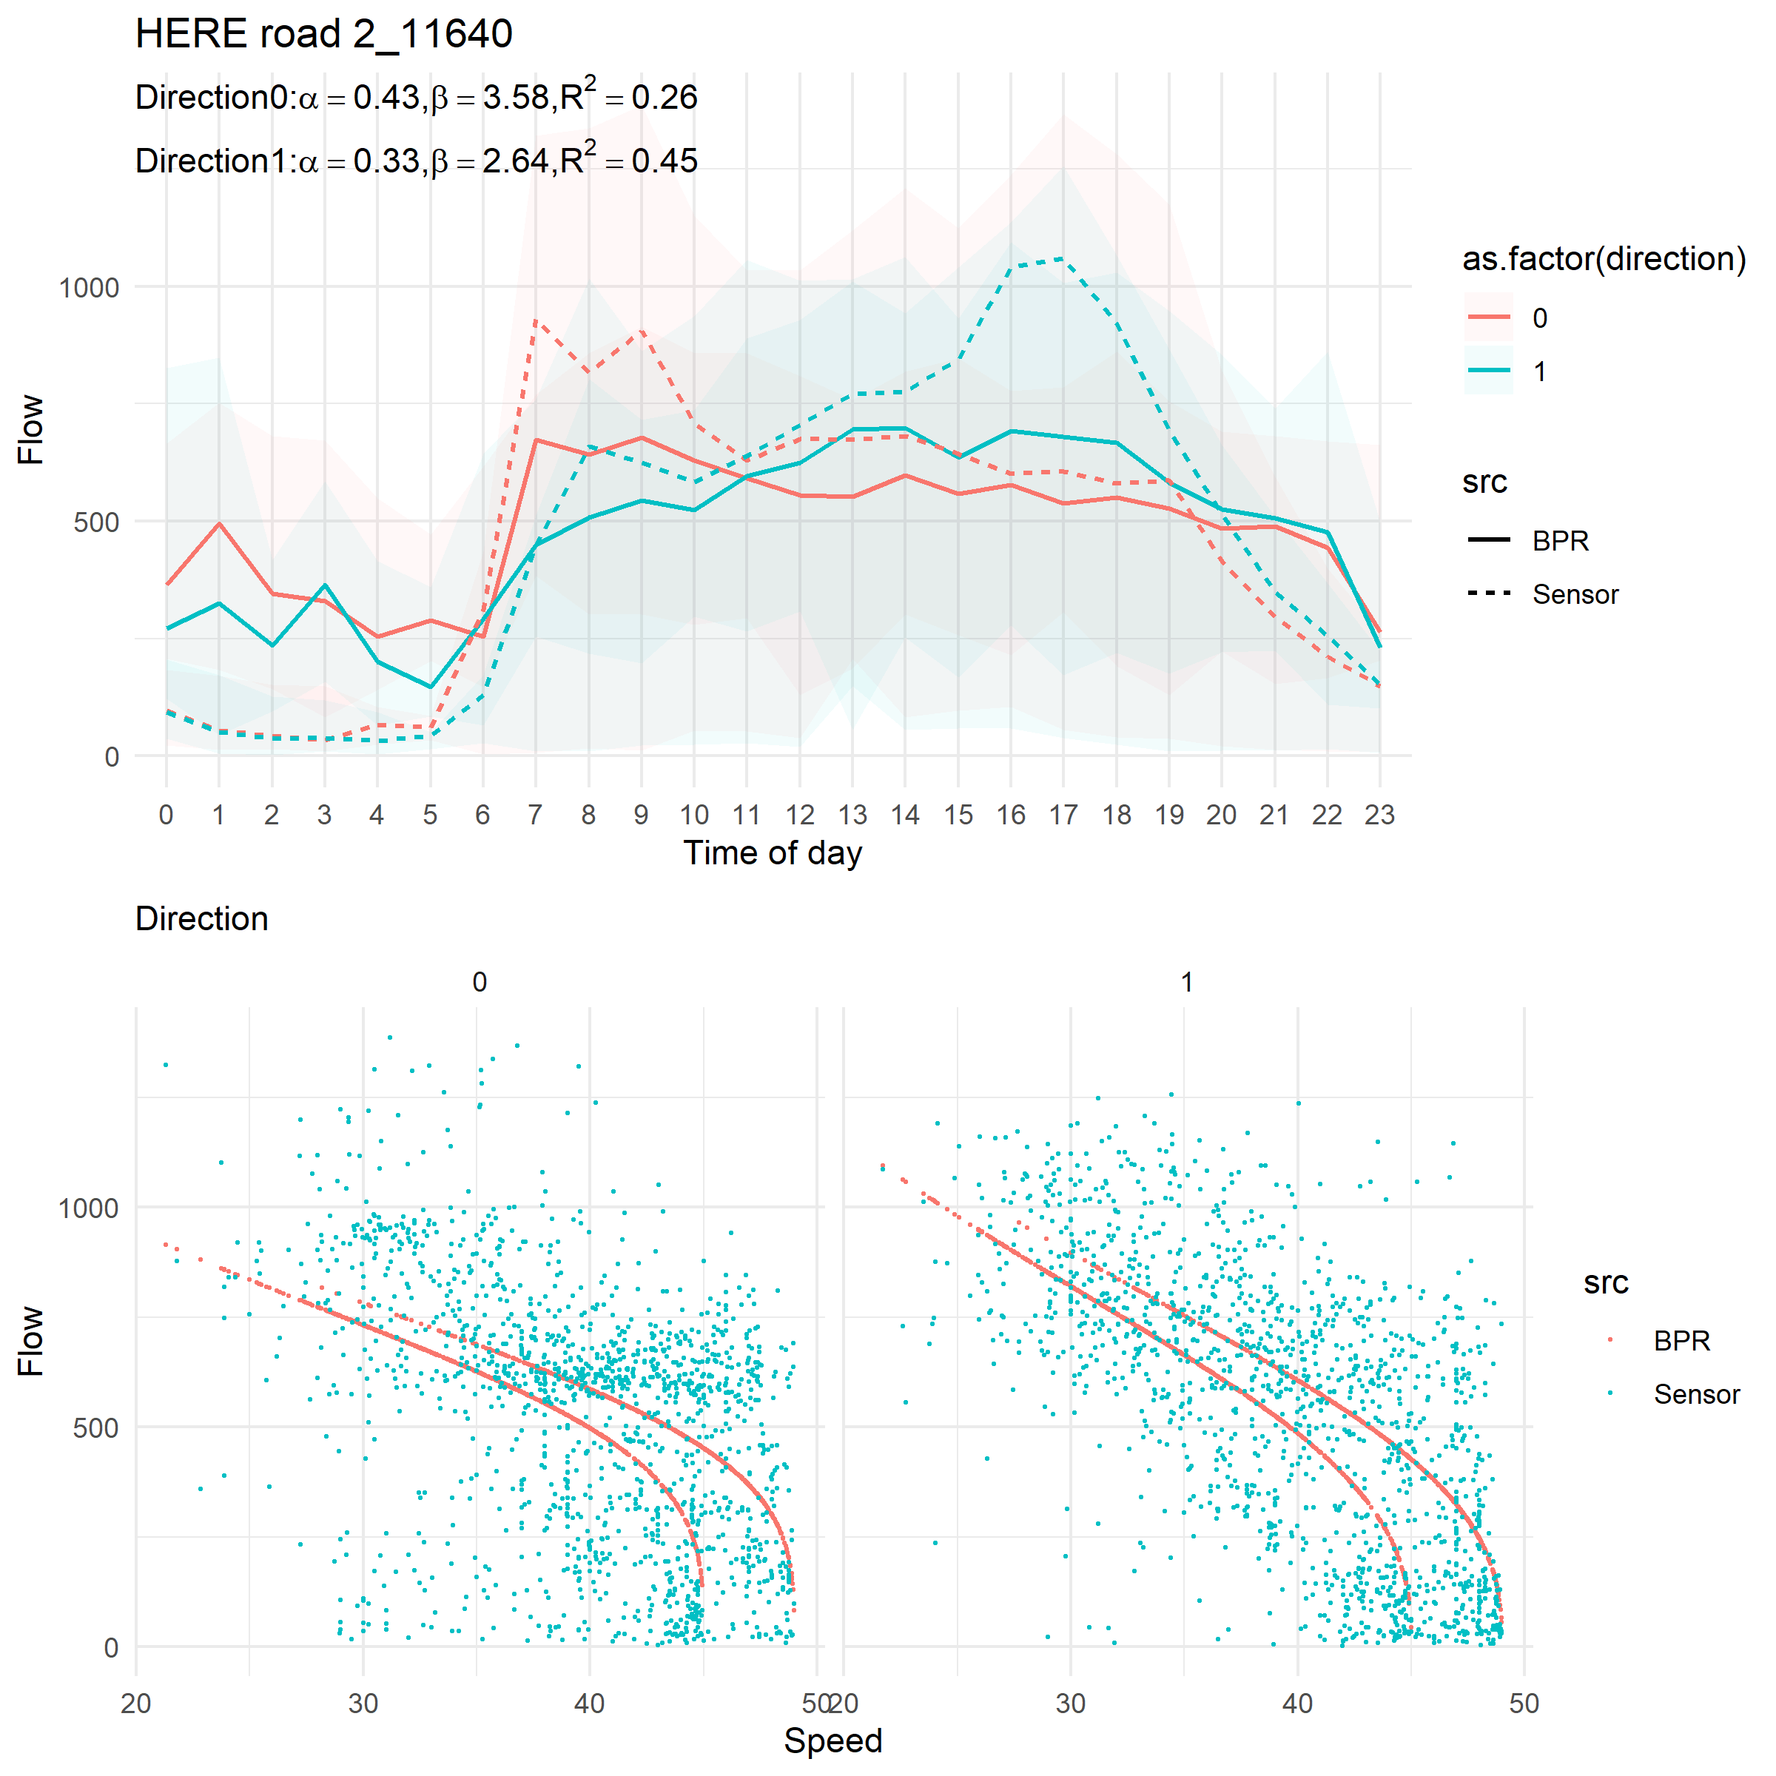

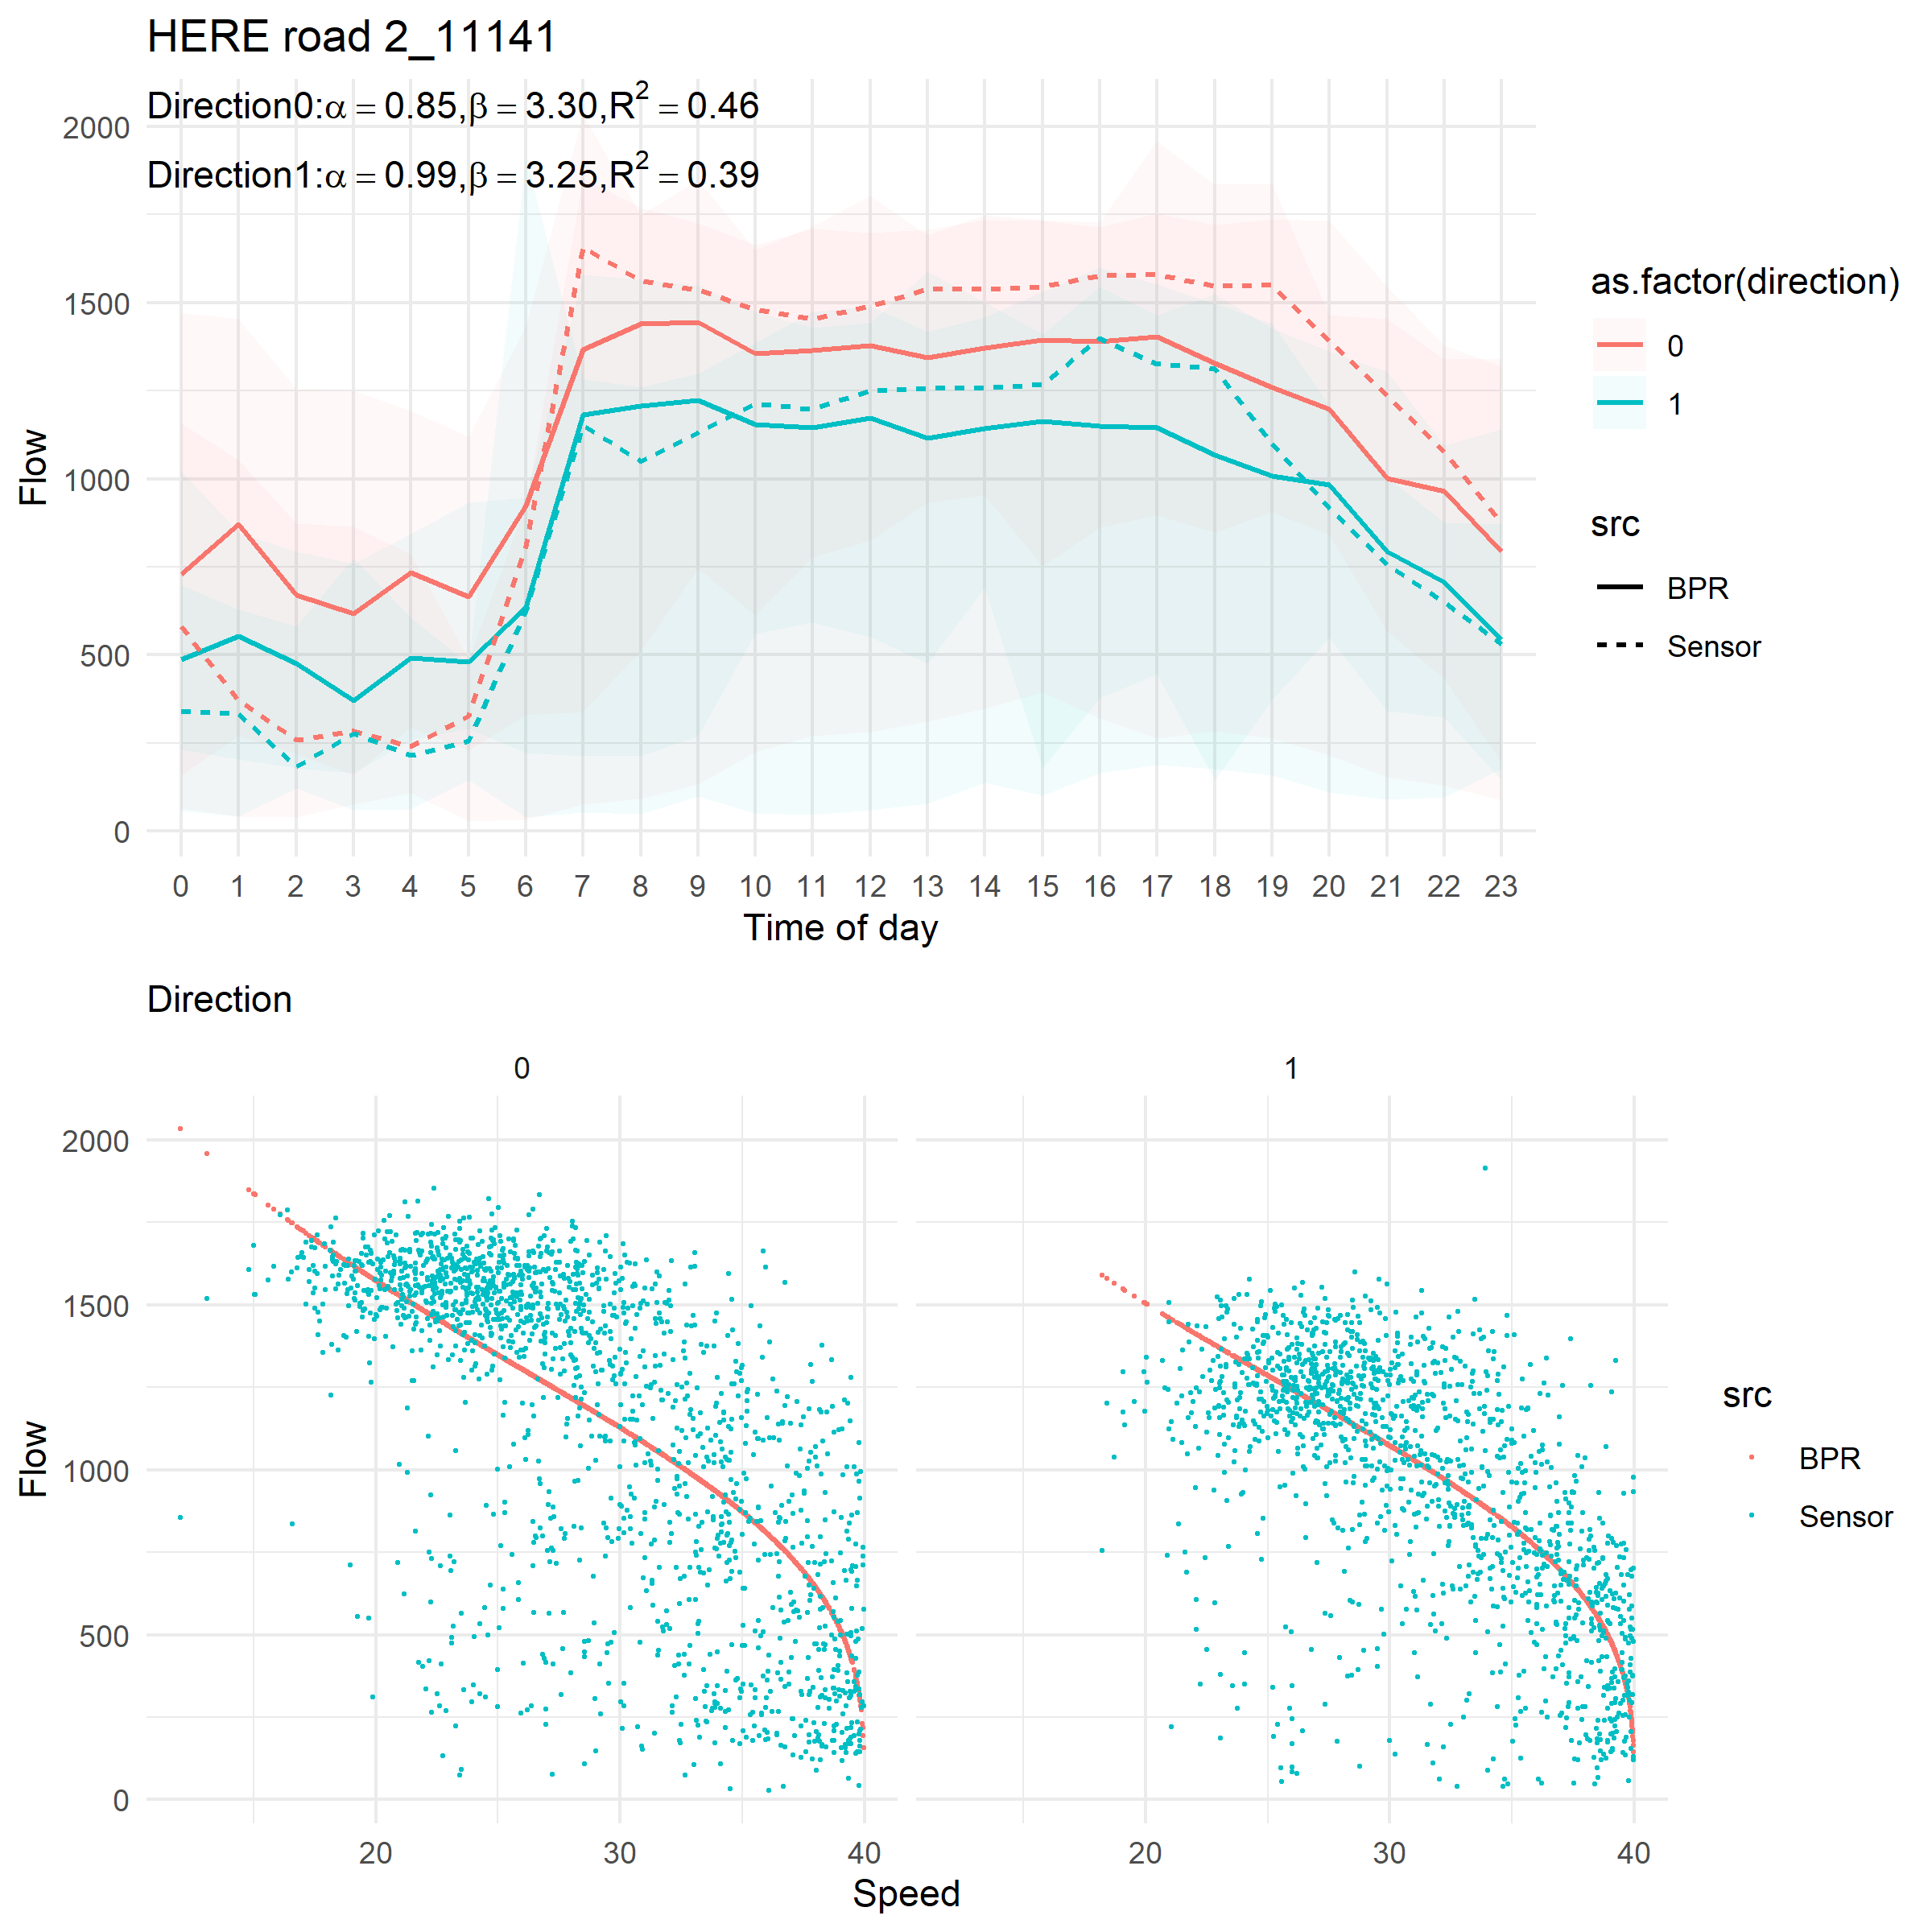

Summary

Given the above problems of data, it is hard to judge the feasibility of BPR in this context. However, the results suggest that BPR performs poor when the speed is low as compared with the sensors’ flow. Moreover, we have no idea how sensitive the parameters are to different road segments given the above problems in the input data.

No matter what method we use, we need to find the right road segments to start with. The road segments should be able to integrate multiple sources and their geolocations.